**Project Design Phase-II Customer Experience Journey Map**

|  |  |
| --- | --- |
| Date | 26. 10. 2022 |
| Team ID | B9-3A5E |
| Project Name | Digital naturalist -AI enable Diversity researcher |
| Maximum Marks | 4 Marks |

**Customer Experience Journey Map :**

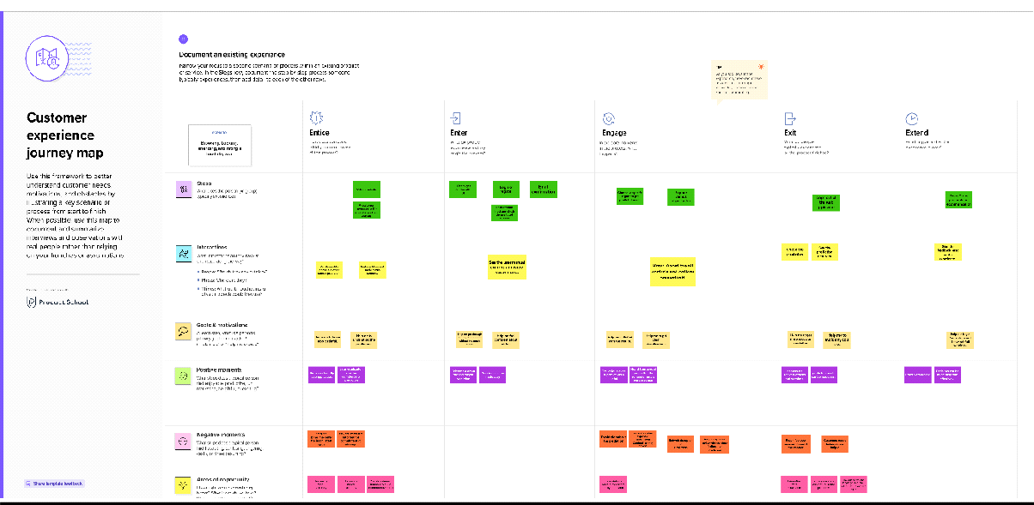

Customer Experience Journey Template : [https://app.mural.co/invitation/mural/sakthimaheshwarim6402/1666072066487?sender=u48fd175](https://app.mural.co/invitation/mural/sakthimaheshwarim6402/1666072066487?sender=u48fd175d7258e297f5151623&key=ffbce469-2b80-46d8-a769-33df0dadff47) [d7258e297f5151623 HYPERLINK "https://app.mural.co/invitation/mural/sakthimaheshwarim6402/1666072066487?sender=u48fd175d7258e297f5151623&key=ffbce469-2b80-46d8-a769-33df0dadff47"& HYPERLINK "https://app.mural.co/invitation/mural/sakthimaheshwarim6402/1666072066487?sender=u48fd175d7258e297f5151623&key=ffbce469-2b80-46d8-a769-33df0dadff47"key=ffbce469-2b80-46d8-a769-33df0dadff47](https://app.mural.co/invitation/mural/sakthimaheshwarim6402/1666072066487?sender=u48fd175d7258e297f5151623&key=ffbce469-2b80-46d8-a769-33df0dadff47)